**BP315 Business Sub-Process Design Document**

**Exception Handling during Picking**

**Cross Industries**

**Extended Warehouse Management**

Table of Contents

1 Overview 3

1.1 Change History 3

1.2 RASCI 3

1.3 Approval Detail 3

1.4 Other Related Documents 3

2 Business Process Overview 4

2.1 High level requirements 5

2.2 Key Value Drivers for the Business Process 5

2.3 Leading Practice Inputs 5

3 Sub-Process Description 5

3.1 Business Sub-Process diagram 6

4 Sub Process Activities 6

4.1 Activity List 6

4.2 Inbound Communication 7

4.3 Outbound Communication 7

4.4 Test Conditions 7

5 Sub-Process Variation 8

5.1 Business Unit Led 8

5.2 Geography/Legal Entity Led 8

6 Role Definition & Organisational Impact 8

6.1 Role/Skill Class Inventory 8

6.2 Role Summary 8

6.3 Organizational Impact 8

7 Process Fitness & Gap Analysis 9

7.1 Process Fitness 9

7.2 Gap Analysis 9

8 RICEFW 9

8.1 Reports 9

8.2 Interfaces (Inbound / Outbound) 10

8.3 Conversions 10

8.4 Enhancements 10

8.5 Forms 10

8.6 Workflows 11

9 Integration Points 12

9.1 Integration Issues 12

9.2 Other issues 12

# Overview

## Change History

|  |  |  |  |  |
| --- | --- | --- | --- | --- |
| Ver. | Date | Summary of Changes | Author | Transport Number |
| 1 | Feb-2020 | Re-work | Aparna Nair |  |
|  |  |  |  |  |
|  |  |  |  |  |

## RASCI

|  |  |  |  |
| --- | --- | --- | --- |
| RASCI | Role | Name | Phone |
|  |  |  |  |
|  |  |  |  |
|  |  |  |  |

R: Responsible; A: Accountable; S: Support; C: Contribute; I: Information;

## Approval Detail

|  |  |  |  |
| --- | --- | --- | --- |
| Review # | Date | Name & Position of Approver | Signature |
| 1 | 8.04.2020 | Vikrant Kumar Madhesia(Team Lead) |  |
|  |  |  |  |

## Other Related Documents

|  |  |
| --- | --- |
| Related Document | Comment |
|  |  |
|  |  |
|  |  |
|  |  |

# Business Process Overview

**Exception Handling:**

To keep the gap between the real world and the system data small over time,detected inconsistencies must be entered in the system as soon as possible. Extended Warehouse management provides advanced functionalities to record and manage exceptions that occur during the warehousing processing in the real time.

Exception handling is fully integrated into EWM. There are around 40 exception codes in the standard

System and we can create as many as we want within the theoretical limits defined by the field size which is four characters.

**Exception code raised during Outbound:**

EXCEPTION CODES:

The exception code basically informs that an exception situation has occured in the warehouse. An exception is when the system may behave differently and return a data which does not match with the expected situation. When an exception code is used,it is a message to the system to either save the information taking into consideration the inconsistency or trigger a follow up action.

For triggering a follow up action, there are several connections available such as SAP Workflow, SAP alert framework, and SAP status management. Exception codes form a very pivotal part of exception handling.

Once we are aware of the business context and the execution step i.e for example whether the execution of the process is in Desktop or RFUI mode, we can configure follow up actions accordingly.

Exceptions that might occur in this business process are the following:

• picker finds a smaller quantity than the requested quantity in the storage bin

• The bin the picker should pick from is not accessible

• packer finds a smaller quantity than the requested quantity in the picking handling unit (HU).

Exception codes are defined by making assignments to the business context, the process code, and the exception code profile. Exception code associated with various exception scenarios include the following:

• Change Batch

• Change Destination Data (HU or Bin)

• Bin denial full and Replenishment

• Bin denial full

• Bin denial partial

• Stock removal denial

• Bin denial partial + replenishment

• Diff. as charges for source bin

• Difference as charges for warehouse

• Picking shortage

These exceptions can be Handled either through:

1. SAP GUI
2. RF terminal

The scope of this document is to handle exception during Picking via SAP GUI.

## High level requirements

* Well defined warehouse structure in EWM
* Master data (Bin, Product…)

## Key Value Drivers for the Business Process

* Detect and record inconsistencies in the warehouse
* Flexibility to record inconsistency using RF terminal or GUI
* Wide coverage for different exceptions

## Leading Practice Inputs

* Flexibility to configure a wide array of exceptions which helps in recording inconsistencies
* Reduces loss of continuity during execution of processes

# Sub-Process Description

The Sub processes identified for Exception handling during Picking are as given below:

1. Sales Order
2. Outbound Delivery
3. Outbound Delivery Request
4. Warehouse Task/Order Creation
5. Insert exception code during picking that is while Warehouse Task/Order Confirmation
6. Goods Issue Posting

## Business Sub-Process diagram

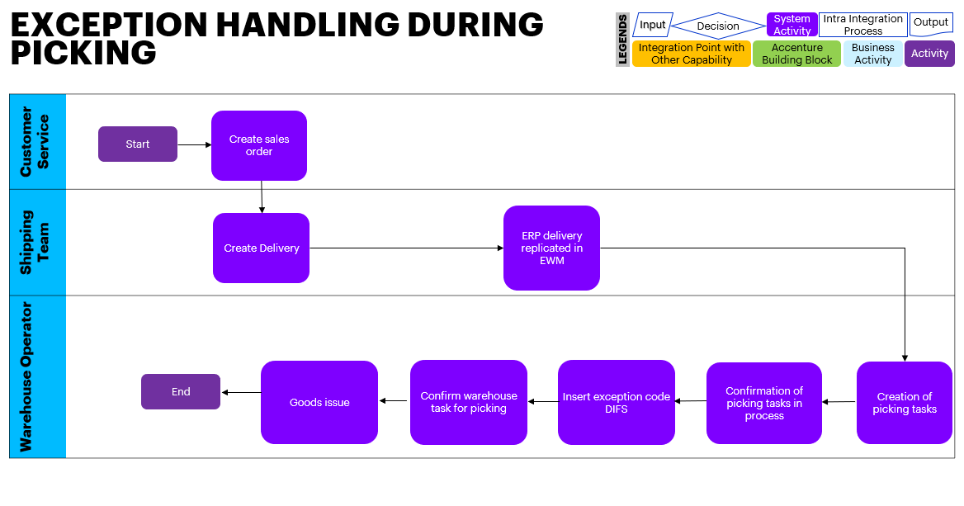

# Sub Process Activities

## Activity List

It maps to the BP317, Activity definition document if applicable for the project & also has references in the process/sub process diagram.

|  |  |  |  |  |
| --- | --- | --- | --- | --- |
| Name | Description | Transaction Code,  if relevant | Roles involved | Regulatory /Other Controls |
| Sales Order creation | Sales Order creation | VA01 | Sales department |  |
| Outbound Delivery | Outbound Delivery | VL01N | Sales department |  |
| Outbound Delivery Request | Outbound Delivery Request | /SCWM/PRDO | Warehouse clerk |  |
| Warehouse Task/Order Creation | Warehouse Task/Order Creation | /SCWM/PRDO | Warehouse clerk |  |
| Enter the Exception code during Picking process Warehouse Task/Order Confirmation | Warehouse Task/Order Confirmation | /SCWM/TO_CONF | Warehouse Operator |  |
| Goods Issue Posting | Goods Issue Posting | /SCWM/PRDO | Warehouse Operator |  |

## Inbound Communication

The Inbound Communication needs to be specifically documented for the client specific situation, like interfacing with external systems, workflow, form & Medium of communication.

|  |  |  |  |  |
| --- | --- | --- | --- | --- |
| Activity | Type (email, form, handoff, etc) | Automatic/Manual | Source | Description |
| NA | NA | NA | NA | NA |
|  |  |  |  |  |

## Outbound Communication

The Outbound Communication needs to be specifically documented for the client specific situation, like interfacing with external systems, workflow, form & Medium of communication.

|  |  |  |  |  |
| --- | --- | --- | --- | --- |
| Activity | Type (email, form, handoff, etc) | Automatic/Manual | Source | Description |
| NA | NA | NA | NA | NA |
|  |  |  |  |  |

## Test Conditions

This section captures Test conditions for this sub process for the any specific client requirements. Generic test conditions for this sub process will be within the AAES test scripts.

|  |  |  |
| --- | --- | --- |
| Number | Test Condition – Action | Expected Result |
| NA | NA | NA |
|  |  |  |

# Sub-Process Variation

## Business Unit Led

None

## Geography/Legal Entity Led

None

# Role Definition & Organisational Impact

## Role/Skill Class Inventory

|  |  |  |
| --- | --- | --- |
| Role | Skills | Knowledge |
| NA | NA | NA |
|  |  |  |
|  |  |  |

## Role Summary

|  |  |  |
| --- | --- | --- |
| Role | List of Steps | SAP Transaction |
| NA | NA | NA |
|  |  |  |

## Organizational Impact

|  |  |  |  |  |
| --- | --- | --- | --- | --- |
| Reference # | Impact Description | Impact (H/M/L) | Impact Type | Impacted Groups |
| NA | NA | NA | NA | NA |
|  |  |  |  |  |
|  |  |  |  |  |

# Process Fitness & Gap Analysis

## Process Fitness

|  |  |  |  |  |
| --- | --- | --- | --- | --- |
| Req ID | Short Description | Long Description | Req. Type | Accenture Reusable Assets |
| NA | NA | NA | NA | NA |
|  |  |  |  |  |

## Gap Analysis

|  |  |  |  |  |  |  |
| --- | --- | --- | --- | --- | --- | --- |
| Country/ Region/ Business Impacted | Gap Description | Legal Req. (Y/N) | Magnitude of Impact (L/M/H) | Solution Type | RICEFW No. | Ref. to Req. id. |
| NA | NA | NA | NA | NA | NA | NA |
|  |  |  |  |  |  |  |

# RICEFW

## Reports

|  |  |  |  |  |  |
| --- | --- | --- | --- | --- | --- |
| Client XYZ  RICEFW # | Report Description | Complexity (H/M/L) | Comments | Use from myConcerto/ARTL (New/Rework/Rep) | Ref # from RICEFW inventory |
| NA | NA | NA | NA | NA | NA |
|  |  |  |  |  |  |
|  |  |  |  |  |  |

## Interfaces (Inbound / Outbound)

|  |  |  |  |  |  |
| --- | --- | --- | --- | --- | --- |
| Client XYZ  RICEFW # | Interface Description | Complexity  (H/M/L) | Comments | Use from myConcerto/ARTL (New/Rework/Rep) | Ref # from RICEFW inventory |
| NA | NA | NA | NA | NA | NA |
|  |  |  |  |  |  |

## Conversions

|  |  |  |  |  |  |
| --- | --- | --- | --- | --- | --- |
| Client XYZ  RICEFW # | Conversion Description | Complexity  (H/M/L) | Comments | Use from myConcerto/ARTL (New/Rework/Rep) | Ref # from RICEFW inventory |
| NA | NA | NA | NA | NA | NA |
|  |  |  |  |  |  |

## Enhancements

|  |  |  |  |  |  |
| --- | --- | --- | --- | --- | --- |
| Client XYZ  RICEFW # | Enhancement Description | Complexity  (H/M/L) | Comments | Use from myConcerto/ARTL (New/Rework/Rep) | Ref # from RICEFW inventory |
| NA | NA | NA | NA | NA | NA |
|  |  |  |  |  |  |

## Forms

|  |  |  |  |  |  |
| --- | --- | --- | --- | --- | --- |
| Client XYZ RICEFW # | Form Description | Complexity (H/M/L) | Comments | Use from myConcerto/ARTL (New/Rework/Rep) | Ref # from RICEFW inventory |
| NA | NA | NA | NA | NA | NA |
|  |  |  |  |  |  |

## Workflows

|  |  |  |  |  |  |
| --- | --- | --- | --- | --- | --- |
| Client XYZ RICEFW # | Workflow Description | Complexity (H/M/L) | Comments | Use from myConcerto (New/Rework/Rep) | Ref # from RICEFW inventory |
| NA | NA | NA | NA | NA | NA |
|  |  |  |  |  |  |

# Integration Points

Generic Integration touch points have been highlighted in this section. It covers dependencies or prerequisites arising from other processes or sub processes. This information should lead to cross functional discussions between different work streams to sort out the interdependencies.

## Integration Issues

|  |  |  |  |  |
| --- | --- | --- | --- | --- |
| Issue # | Issue Description | Impact | Status | Resolution |
| NA | NA | NA | NA | NA |
|  |  |  |  |  |

## Other issues

|  |  |  |  |  |
| --- | --- | --- | --- | --- |
| Issue # | Issue Description | Impact | Status | Resolution |
| NA | NA | NA | NA | NA |
|  |  |  |  |  |

#### Revision History

|  |  |  |  |
| --- | --- | --- | --- |
| Date | Version | Description | Author |
| 05/02/2020 | 1 | Re-work | Aparna Nair |
|  |  |  |  |